# Configuring the Project

1. To launch the make command, go to File -> Preferences -> Settings.

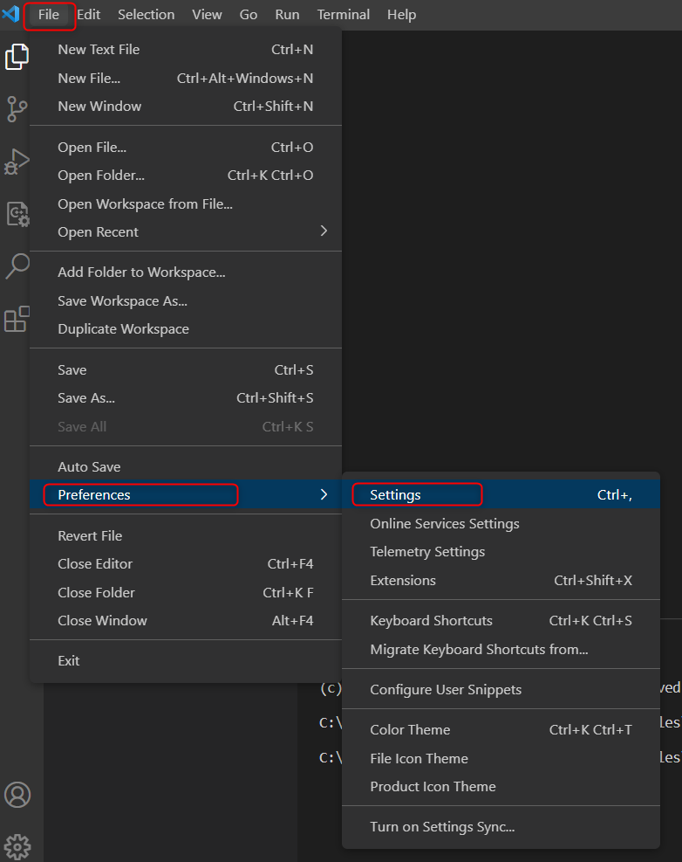

Figure 16: Settings

1. Goto: Settings -> Extensions and select MakefileTools.

Figure 17: Configuring the Makefile Tools extension

1. Enter the make file path in path setting

Figure 18: Applying the Makefille path

1. Select MakeFile extension in the activity bar and set Build target as [all].

Figure 19: Makefile Tools extension - Build target

1. Click on the Build icon available in the Extension window. This will launch the make and generate the ELF files.

Figure 20: Building the application

1. Click on the RUN icon in Extension window. This will launch make and generates the out directory inside the application directory along with the ELF files.

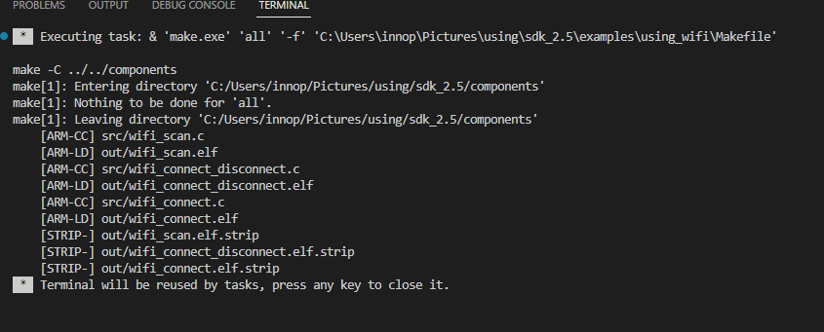

Figure 21: Out directory generation - Terminal window